***Note***: If using updated node modules (node version greater than 12), then done needs to be removed from the spec file (argument and method). If using older versions then, it stays.\*

Defining an Endpoint

An **endpoint** is the **URL** of the **REST API** with the method that *gets*, *adds to*, or *modifies* the *data* of an API in some way.

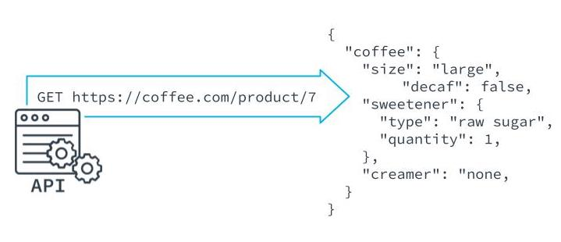

An Endpoint is the URL of a REST API

Benefits of Endpoint Testing

* Confirms that the server is working.
* Confirms that endpoints are configured properly.
* More efficient than manual testing.

Adding a Framework for Endpoint Testing

Endpoint testing is not native to Jasmine and requires a third-party framework, like **[Supertest](https://www.npmjs.com/package/supertest" \t "_blank)** to test the status of responses from servers.

Setting Up Endpoint Testing

* Install Supertest as a dependency.

$ **npm** i supertest

* Add type definition to allow the code to compile without TypeScript errors.

$ **npm** i --save-dev @types/supertest.

* Import SuperTest in the spec file.

**import** supertest **from** 'supertest';

**import** app **from** '../index';

**const** request = **supertest**(app);

**describe**('Test endpoint responses', () => {

**it**('gets the api endpoint', **async** (done) => {

**const** response = **await** request.**get**('/api');

**expect**(response.status).**toBe**(200);

**done**();

}

)});

* Create and Run Tests

$ **npm** run **test**

New Terms

| **Term** | **Definition** |
| --- | --- |
| Endpoint | An endpoint is the URL of the REST API with the method that gets, adds to, or modifies the data of an API in some way |